

UNMANNED AERIAL VEHICLE (uaV) FOR STRUCTURAL HEALTH OF BRIDGE MONITORING

CPE PRACTICE AND DESIGN 1



**UAV FOR STRUCTURAL MONITORING OF BRIDGE HEALTH**

A RESEARCH PROPOSAL

PRESENTED TO THE FACULTY OF THE COLLEGE OF ENGINEERING

EASTERN SAMAR STATE UNIVERSITY

BORONGAN CITY, EASTERN SAMAR, PHILIPPINES

A COURSE REQUIREMENT FOR

CPE PRACTICE AND DESIGN 1

UNDER THE DEGREE

BACHELOR OF SCIENCE IN COMPUTER ENGINNERING

YAKIT, DIONESIO JR. P

BERNAS, KARMELA G.

ESPINEDA, ROY LOIUE S.

PLATA, ALMIRA L.

CARATAY, AMOR B.

CASARINO, NIÑO MELLORD B.

2025

**CHAPTER 1**

**Introduction**

**BACKGROUND OF THE STUDY**

Bridges serve as critical components of a nation’s transportation infrastructure, enabling the safe, reliable, and efficient movement of people, goods, and services across regions. They are vital links that support economic activity, social connectivity, and disaster response operations. However, over time, these structures are continuously exposed to a variety of external and internal stressors such as harsh environmental conditions, corrosion due to moisture and pollutants, load-induced fatigue from increasing traffic volumes, vibrations caused by heavy vehicles, and natural hazards like earthquakes, floods, and typhoons. In addition, the inevitable material degradation associated with aging infrastructure further threatens the long-term safety and serviceability of bridges. If left unmonitored, these factors can gradually weaken the structural integrity of a bridge, potentially leading to unexpected failures. Bridge collapses not only result in tragic loss of lives but also cause significant economic disruption, traffic congestion, costly emergency repairs, and interruptions to essential public services. This makes the case for continuous and accurate **Structural Health Monitoring (SHM)** systems even more urgent, as they provide the means to detect anomalies at an early stage, facilitate timely interventions, and prevent catastrophic consequences.

Traditional approaches to bridge inspection have largely relied on manual visual assessments performed by trained inspectors. While this method remains important, it is often limited by several challenges. The process is labor-intensive and time-consuming, requiring inspectors to access hazardous or hard-to-reach sections such as tall piers, the underside of decks, and confined cavities. In some cases, scaffolding, specialized vehicles, or even temporary closures are needed, further increasing inspection costs and creating inconvenience for the public. More critically, visual inspections can only reveal surface-level damages; subtle internal issues such as microcracks, reinforcement corrosion, or early material fatigue may remain undetected until they progress to severe conditions. These limitations underscore the need for innovative approaches that go beyond conventional inspection techniques.

In this context, the integration of **embedded systems** into SHM has emerged as a promising solution. An embedded system, consisting of compact hardware and specialized software, is designed to perform specific monitoring tasks reliably and efficiently. In bridge applications, such systems can continuously acquire data from advanced sensors—such as LiDAR, ultrasonic transducers, vibration sensors, and obstacle avoidance modules—and process it in real time to detect anomalies or deviations from normal behavior. These systems can either analyze data locally using microcontrollers like Arduino or STM32 or transmit it to remote servers for advanced analysis through cloud-based platforms. Equipped with features such as low power consumption, miniaturization, and robustness, embedded systems are particularly suitable for long-term deployment in remote and unattended environments, making them highly practical for infrastructure monitoring.

The effectiveness of embedded SHM systems is further amplified when combined with modern wireless communication technologies. Modules such as **LoRa**, **GSM**, or **Wi-Fi** enable seamless data transfer from bridge-mounted sensors to centralized monitoring stations, allowing engineers and decision-makers to receive timely updates regardless of their location. Moreover, the integration of aerial platforms, particularly drones equipped with high-resolution cameras, LiDAR scanners, or even Ground Penetrating Radar (GPR), provides an additional layer of inspection capability. Drones can access areas that are otherwise dangerous or impossible for human inspectors to reach, capturing detailed visual and spatial data while significantly reducing inspection time and risks. Together, these technological advancements represent a shift towards digitized and automated infrastructure monitoring, aligning with the global movement towards **smart cities, intelligent transportation systems, and Industry 4.0**.

By leveraging embedded systems integrated with wireless communication and aerial inspection technologies, stakeholders gain the ability to transition from reactive maintenance—repairing damage only after it becomes severe—to predictive and preventive maintenance strategies. This not only extends the service life of bridges but also optimizes resource allocation, reduces overall maintenance costs, and enhances public safety. Furthermore, such systems contribute to sustainability by minimizing unnecessary material replacements and supporting data-driven decision-making in infrastructure management. Ultimately, this study seeks to explore, design, and implement an **embedded system solution specifically tailored for real-time bridge monitoring**, with a strong emphasis on balancing cost-effectiveness, reliability, and deployment feasibility. The outcome is envisioned to provide a scalable framework for modernizing bridge inspections, ensuring safer infrastructure, and contributing to the broader goal of building resilient, sustainable, and smart urban environments.

**STATEMENT OF THE PROBLEM**

Manual inspection of bridges is often **time-consuming, costly, and potentially hazardous to engineers**, especially when dealing with large-scale structures, elevated spans, or hard-to-access locations such as the underside of decks, tall piers, and confined cavities. Inspectors may be required to use scaffolding, aerial lifts, or rope-access techniques, all of which add to the risks, complexity, and cost of the inspection process. These traditional approaches, while still widely practiced, face limitations in terms of frequency, accuracy, and consistency. In many cases, inspections are carried out only at scheduled intervals, which may leave long periods where subtle but critical deterioration goes unnoticed. Issues such as fatigue cracks, corrosion of reinforcement, and early-stage material degradation may progress silently between inspection cycles, resulting in delayed maintenance and, in the worst cases, catastrophic failure.

Another significant drawback of human-based inspection is its **inherent subjectivity**. Two different inspectors may assess the same defect differently depending on their experience, perspective, or environmental conditions during the assessment. This lack of standardization can lead to inconsistent data collection and reporting, making it difficult to establish a reliable long-term record of structural health. Visual inspections are also limited to what the human eye can detect, often overlooking micro-level damage such as hairline cracks, internal corrosion, or early delamination within concrete elements. As a result, damage may only become apparent when it has already reached an advanced and costly stage to repair.

In addition, automated monitoring reduces reliance on risky human involvement in hazardous areas. Instead of sending inspectors to dangerous positions, embedded systems and aerial drones equipped with high-resolution cameras, LiDAR, or other specialized sensors can safely and efficiently capture critical data. This not only minimizes risks to human safety but also lowers operational costs and reduces disruptions to bridge users during inspections. In the long term, adopting automated monitoring systems represents a proactive approach to **infrastructure management**, enhancing safety, extending the lifespan of bridges, and ensuring uninterrupted service to the public.

**AIMS AND OBJECTIVES**

This study aims to design and develop a smart monitoring system using embedded technology and drone integration for bridge inspection. The specific objectives include:

* To design an embedded system capable of continuously monitoring the structural health of a bridge.
* To detect external cracks LiDAR, Obstacle Avoidance senor.
* To implement wireless data transmission to a central dashboard for analysis.
* To enable autonomous data collection using a drone-mounted system

**SIGNIFICANCE OF THE STUDY**

1. Structural Engineers and Inspectors – This study will provide them with an innovative tool for monitoring the health of bridges more efficiently. Instead of relying solely on manual inspections, engineers can access real-time, accurate data that supports early detection of cracks, deformations, or other structural anomalies. This will enhance predictive maintenance and reduce the likelihood of unexpected failures.

2. Government Agencies and Policymakers – The system offers a cost-effective and data-driven solution for infrastructure management. By integrating UAVs with embedded monitoring systems, agencies can improve maintenance planning, allocate resources more effectively, and ensure the safety and reliability of transportation networks. This aligns with long-term infrastructure sustainability programs.

3. Researchers and Academics – The study contributes to the growing field of smart infrastructure and civil engineering innovation. It may serve as a reference for future research on UAV-based monitoring systems, embedded technologies, and their applications in structural health monitoring and smart city development.

4. Communities and the General Public – Since bridges are critical to everyday mobility and commerce, the successful implementation of this system will improve public safety, reduce the risks of bridge accidents, and ensure more reliable transportation routes. Ultimately, this benefits society by minimizing disruptions and supporting economic activities.

5. Technology Developers and Innovators – The project may inspire further advancements in the integration of UAVs, sensors, and wireless communication technologies. It opens opportunities for collaboration in developing more efficient, scalable, and intelligent monitoring solutions for broader applications beyond bridges.

**SCOPE AND LIMITATION**

This study involves the development of a prototype embedded system integrated with a camera, capturing images and videos of hard-to-reach or dangerous areas of the bridge, such as the underside of decks, tall piers, and confined spaces. This drone is also equipped with LiDAR and obstacle avoidance sensors. This allows the drone to generate accurate 3D point clouds of the bridge’s surface, enabling mapping of deformations, surface cracks, and geometric anomalies with the LiDAR system. The obstacle avoidance feature increases the safety and reliability of close-up inspections, particularly when navigating beneath decks or around piers and trusses. The data is wirelessly transmitted to a centralized dashboard or cloud platform for analysis. However, the project is limited to a small-scale implementation due to financial and technical constraints. Environmental conditions such as strong winds or heavy rain may affect the drone’s performance, while the system’s battery life and coverage will be constrained by the chosen hardware components. Additionally, the prototype will only detect specific types of structural damage that correspond to the capabilities of the selected sensors.

**DEFINITION OF TERMS**

**A. Drone frame:** An FPV drone frame is the structural backbone of a drone. It is the skeleton on which all other components are mounted, and provides protection to all the electronics inside the drone. A typical FPV drone frame is made of carbon fiber plates and metal hardware: 4x Arms. Top and bottom plates.

**B. Motor:** A drone electric motor converts electrical energy into mechanical energy. A motor consists of a stator, a rotor, an iron core, and a main part of a magnet.

**C. Propeller:** A drone propeller is a rotary fan or a spinning blade that is connected to a motor that produces lift & thrust by allowing the drone to fly, maneuver, and hover. The spinning blades create variations in air pressure, which allows the drone to move, ascend, and descend in various directions.

**D. Drone Radio Transmitter:** An FPV Drone Radio Transmitter is an electronic device that uses radio signals to transmit commands wirelessly via a set radio frequency over to the Radio Receiver, which is connected to an aircraft or multirotor being remotely controlled.

**E. Drone Radio Receiver:** A radio receiver, also known as RX, is what will let your drone talk to your remote. Your radio receiver is what will pick up and listen to the stick inputs you give on your radio controller.

**F. ESC:** ESC (Electronic Speed Control) is an electronic device used in drones to regulate the speed and direction of the motors by controlling the power delivered to them.

**G. Battery:** Drone batteries are rechargeable batteries that power drones. They are usually made of Lithium Polymer (LiPo) or Lithium-ion Polymer (Li-ion) and come in different sizes and capacities. Drone batteries are essential for longer flight times, and they pose a potential fire hazard if not handled properly.

**H. Raspberry Pi 5**: provides the computing power required for running your drone's software and controlling its various functions.

**I. Sandisk class:** The Application Performance Class 1 (A1) was defined by SD Physical 5.1 specification. Not only for storing maps, pictures, videos, music, dictionary and documents, it also enables the user to be freed from sluggish for editing and updating data.

**J. LiDAR**: LiDAR stands for Light Detection and Ranging and is a method of remote sensing that creates digital 3D replicas of the real world.

**K. Camera:**  A drone camera is a specialized camera mounted on a drone —also known as an Unmanned Aerial Vehicle (UAV)—designed to capture high-quality images and video while the drone is flying.

**L. Pixhawk:** Pixhawk is a project responsible for creating open-source standards for the flight controller hardware that can be installed on various unmanned aerial vehicles.

**M. GPS:**  A GPS drone is an unmanned aerial vehicle (UAV) equipped with a Global Positioning System (GPS) module. This advanced technology enables the drone to determine its precise geographical location by connecting to a network of satellites orbiting the Earth.

**N. Power Module:**  Power Modules provide a regulated power supply for the flight controller (FC), along with information about battery voltage and current. The voltage/current information is used to determine the consumed power, and to hence to estimate remaining battery capacity.

**O. Safety Switch & Buzzer:**  A buzzer (or Tone Alarm) can be used to audibly indicate status changes for the vehicle. Depending on board capabilities, this can be an active device. A safety switch can be used to enable/disable the outputs to motors and servos. The switch controls the “Safety” state of the vehicle.

**CHAPTER 2:**

**REVIEW OF RELATED LITERATURE AND STUDIES**

**LITERATURE REVIEW**

Bridges are vital for transportation and economic activity, but they are vulnerable to aging, stress, and damage over time. Structural health monitoring (SHM) plays a crucial role in identifying early signs of deterioration to prevent accidents and improve public safety. The evolution of SHM has moved from manual inspection methods to more sophisticated, automated systems incorporating embedded technology, sensors, and drones.

Embedded systems have become widely used in engineering applications due to their flexibility, low power consumption, and ability to function autonomously. In bridge monitoring, they can support a wide array of sensors—LiDAR, Obstacle Avoidance sensor—to provide a real-time assessment of structural integrity. When connected through wireless technologies like GSM or LoRa, these systems enable long-distance, real-time communication and analysis.

Autonomous drones further expand SHM capabilities. They can be equipped with high-resolution cameras, LiDAR, or thermal sensors to conduct aerial inspections, especially in areas inaccessible or dangerous for human inspectors. The convergence of drone technology and embedded systems allows for comprehensive monitoring, enabling predictive maintenance and reducing manual labor and risk.

**RELATED READINGS, LITERATURE, AND STUDY**

1. Hoskere et al. (2019) explored deep learning-based computer vision systems mounted on drones for damage detection in bridges. Their study showed how UAVs could collect visual data that, when analyzed by AI models, significantly improved the efficiency and reliability of bridge inspections.
2. Moyo & Brownjohn (2002) highlighted the importance of long-term structural monitoring using embedded strain gauges and accelerometers in highway bridges. Their research emphasized the importance of real-time monitoring to avoid structural failures.
3. Wu et al. (2017) developed an IoT-based real-time bridge monitoring system integrating wireless sensors and cloud platforms. Their system enabled remote access and alerts, significantly reducing the inspection response time.
4. Reyes & De Vera (2020) implemented a prototype embedded system in Philippine bridge infrastructure using Arduino-based sensors to track tilt and vibration. The results demonstrated potential for low-cost, localized SHM systems in developing countries.
5. Garcia et al. (2022) investigated drone-based visual inspections in rural areas of Luzon. Their study emphasized how drones effectively reduced time, cost, and safety risks during routine infrastructure assessments.

**THEORETICAL FRAMEWORKS**

This study is grounded in Cyber-Physical Systems (CPS) Theory, which integrates computation, networking, and physical processes. In this framework, embedded systems serve as the "cyber" component that interacts with the physical world through sensors and actuators. CPS is widely applied in smart infrastructure, enabling systems to sense, analyze, and respond to environmental conditions in real time.

Key elements of CPS in this study include:

* Sensors and embedded processors monitoring bridge behavior.
* Wireless communication modules transmitting real-time data.
* Autonomous drones as mobile sensor platforms.
* Data analysis dashboards that inform maintenance decisions.

This theoretical lens supports the integration of embedded computing and real-time sensing into civil infrastructure management.

**CONCEPTUAL FRAMEWORKS**

The conceptual framework of this study revolves around an embedded system–based drone platform for bridge structural health monitoring, composed of four main components:

|  |  |  |
| --- | --- | --- |
| **Input** | **Process** | **Output** |
| Strain gauges | Data acquisition by the microcontroller (e.g., Raspberry Pi) | Live data visualization on a dashboard (PC or mobile) |
| LIDAR sensors | Filtering and pre-processing of raw sensor signals | Real-time alerts |
|  | Alert generation based on threshold analysis | Exportable reports for engineering review |
|  | Data logging and timestamping | Historical data graphs for trend analysis |

The interaction of these components supports automated, real-time, and remote monitoring of bridge structures.

**SYNTHESIS AND JUSTIFICATION**

From the reviewed literature, it is evident that embedded systems and drones significantly improve the monitoring and maintenance of bridge infrastructure. International studies demonstrate the effectiveness of these technologies in automating inspections, reducing costs, and enhancing accuracy. Local research confirms their viability in the Philippine context, particularly for remote or hazardous locations.

However, gaps remain in implementing a fully integrated system that combines both embedded sensing and drone-based inspections in a unified, real-time monitoring solution tailored to local needs. This study addresses that gap by proposing a cost-effective and scalable system using open-source hardware and adaptable drone platforms. It is justified by the need for safer, faster, and more consistent monitoring practices in bridge maintenance and public safety.

**CHAPTER 3**

**METHODOLOGY**

This chapter outlines the research methodology employed in the development of the proposed project entitled *“Unmanned Aerial Vehicle (UAV) for Structural Health of Bridge Monitoring.”* It discusses the systematic approach taken in carrying out the study, including the research design, methods of data gathering, and the statistical treatments applied to evaluate system performance. The methodology also describes the tools, instruments, and technologies integrated into the system to ensure accuracy and reliability in data collection and analysis. Furthermore, the chapter introduces the IPO (Input-Process-Output) model, which serves as the conceptual foundation for the system’s functional architecture, illustrating how sensor inputs, data processing, and output mechanisms are interlinked to achieve the study’s objectives. By presenting these elements in detail, the methodology provides a structured framework that guides the overall implementation, testing, and validation of the UAV-based monitoring system.

**METHODOLOGY**

The methodology for this project follows a developmental research approach, aimed at designing, building, and testing an embedded system capable of monitoring key parameters indicative of a structure of bridge health. The methodology includes the following phases:

**1. Planning and Requirements Gathering**

Identification of bridge health indicators such as vibrations, stress, tilt, cracks, and environmental conditions.

Determining sensor requirements, power constraints, and communication protocols.

**2. System Design**

Designing a modular embedded system architecture consisting of sensing, processing, communication, and user interface modules.

Selecting suitable hardware components (e.g., Raspberry Pi, sensors, communication modules).

**3. Prototype Development**

Integration of sensors and microcontroller units.

Firmware development for real-time sensor data acquisition and transmission.

Program the components (camera, gimbal, aviodance, raspberry pi 5) to make the drone well functioned

**4. Software Interface Design**

Developing a user-friendly dashboard for live monitoring and alerts.

Programming backend systems for logging, visualization, and data retrieval.

**5. Testing and Evaluation**

Laboratory testing on scaled bridge models.

Field testing under real bridge conditions.

Evaluating system accuracy, responsiveness, reliability, and power efficiency.

**RESEARCH DESIGN**

This study uses an experimental-developmental research design where a prototype system is developed and tested through simulation and real-world deployment. The following components define the design:

1. **Independent Variables**: Type of sensors, data collection intervals, sensor placement.
2. **Dependent Variables**: Accuracy of sensor readings, transmission latency, power consumption, system reliability**.**
3. **Control Variables:** Bridge environment (same location during test), constant power supply, controlled vibrations in lab.

The goal is to observe how varying hardware and software configurations affect the system's performance in structural health monitoring tasks.

**STATISTICAL TREATMENT**

Quantitative data collected from the sensors will be analyzed using descriptive statistics in Microsoft Excel:

1. **Mean and Standard Deviation**: To evaluate the average and variability of sensor readings.
2. **Range and Variance**: To assess fluctuation in structural behavior under stress.
3. **Graphical Analysis**: Time series plots to show changes over time. (e.g,. bridge tilt or displacement).
4. **Correlation Analysis**: To compare different sensor outputs (e.g,. vibration vs. tilt).

These statistical methods ensure that trends and abnormalities in structural performance are accurately identified and interpreted.

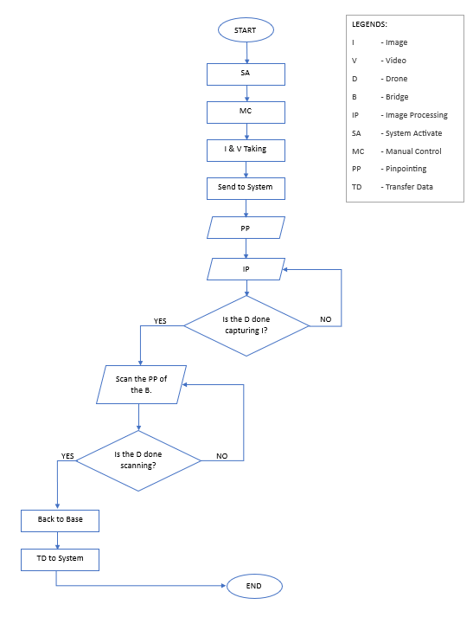

1. **DRONE SYSTEM FLOWCHART**

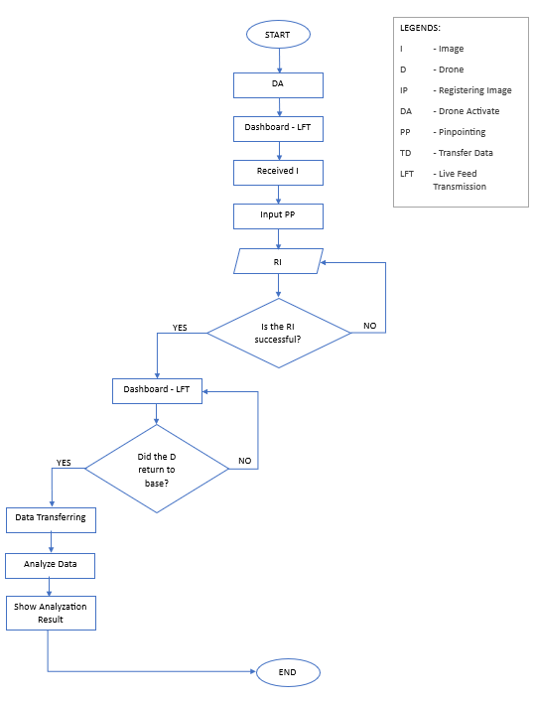

**2. SOFTWARE SOLUTION FLOWCHART**